# Project Development Phase

# SPRINT 4

|  |  |
| --- | --- |
| Date | 13 November 2022 |
| Team ID | PNT2022TMID52611 |
| Project Name | Project - Detecting Parkinson’s Disease using Machine Learning. |

# Sprint 4 Task:

* *Test Vital page*
* *Integrate the result page with the ML model.*
* *Random forest model with 87 percent is deployed for classification*

**Sprint 4 Output:**

**Login page :**

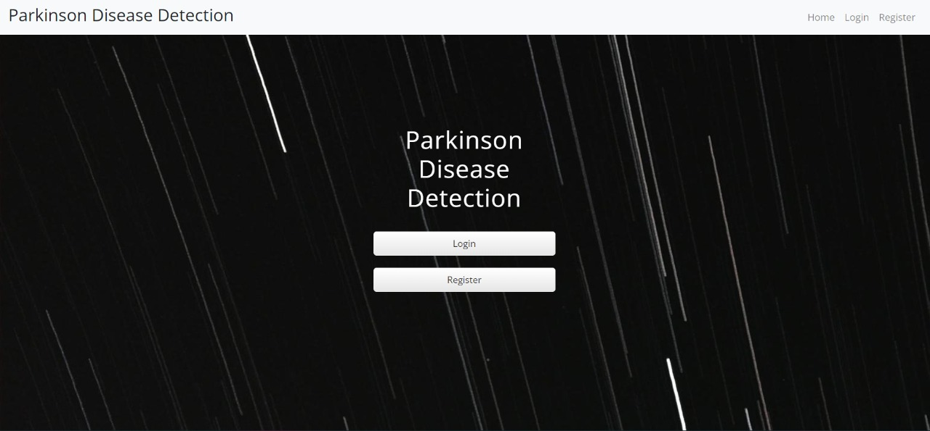

**Registration Page :**

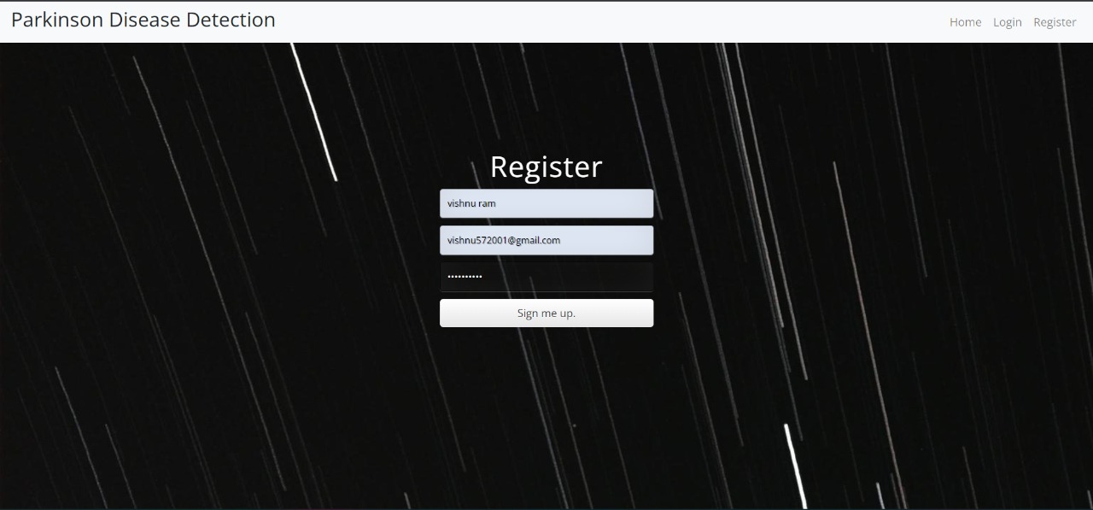

**Database to store user information and Login Credentials.**

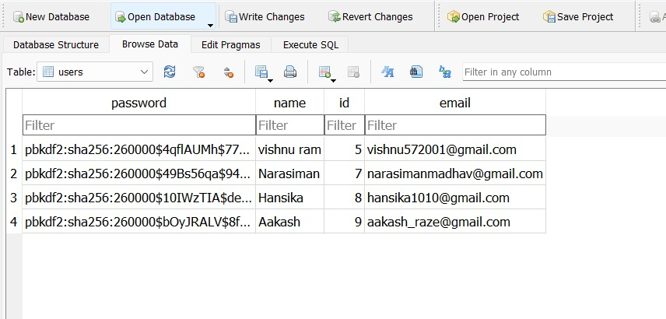

**Login Page**

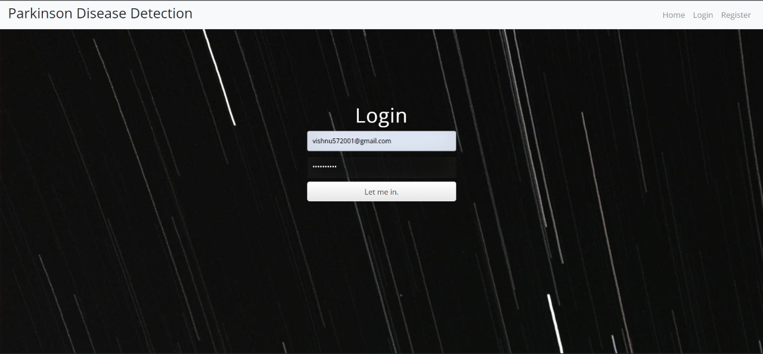

**Result page :**

Not Parkinson:

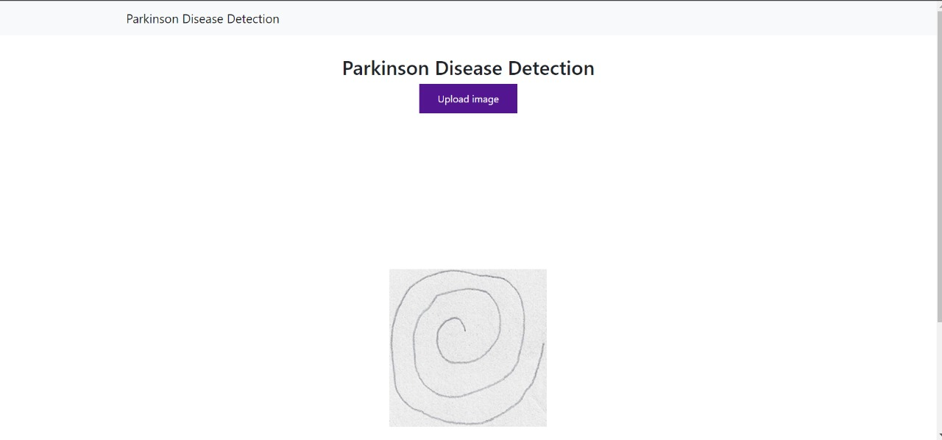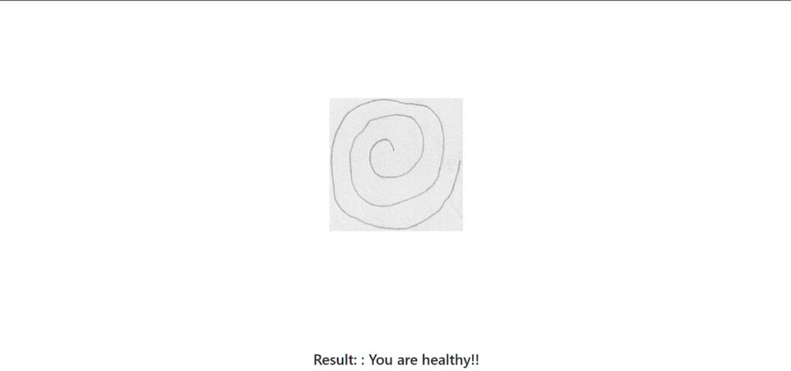

Parkinson Disease Detected:

